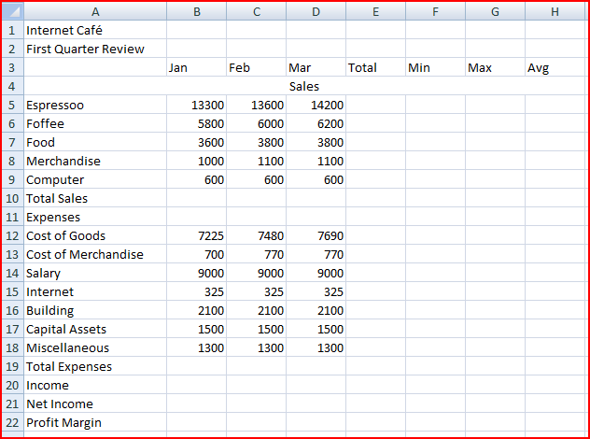

- Make a copy of the sheet 1. Rename the new sheet to final.
- Spell check
- Use excel research to find another word for Salary with the same meaning
- Unmerge A4:H4
- Insert one row above Capital Assets
- Type “Advertising”, “600”, “600”, “600”.
- Find Total, Minimum, Maximum, Average of column Total, Min, Max, Avg
- Find Total Sales, Total Expenses, Net Income (=Total Sales-Total Expenses) of B10:H10, B20:H20, B22:H22
- Find Profit Margin of B23:E23. Profit Margin is equal to “Net Income”/”Total Sales”. Change to percentage with two decimal places.
- B5:H10, B12:H20, B22:H22 – Account format with 0 decimal place
- Hide column F, G
- Merge and Center – A1:H1
- Merge and Center – A2:H2
- A1 and H2:
  - Font : Garamond
  - Font Size: 16
  - Font Style: Bold
  - Font Color: purple
  - Background color: orange
- B3:H3
  - Font: Gill Sans MT
  - Font Size: 11
  - Font Style: Bold, Underline
- A5:A9, A12:A19
  - Font: Gill Sans MT
  - Font Size: 11
  - Font Style: Italic
  - Indent
- A10, A20, A22
  - Font: Gill Sans MT
  - Font Size: 11
  - Font Style: Bold
  - Align: Right
- A10, A20, A22, A23
  - Background color: orange
- E5:E10
  - Background color: light purple
- E12:E20
  - Background color: light blue
- E22
  - Background color: light pink
- A1:H23
  - Thick border
- Freeze Column A
- Insert a row above row 1
- Insert Clip Art
  - Search for: automatic drip coffeemakers
  - Search in: Web Collections
  - Results should be: Photographs -> JPEG
  - Crop the coffee cup
  - Resize
  - Rotate
  - Add border (Simple Frame, Black)
  - Picture Effects: Shadow -> Offset Bottom
  - Picture Effects: Reflection Variations -> Tight Reflection, touching
- Hide Row 5
- A4:D10
  - Insert Chart on the same page: Column -> 2D Clustered Column
  - Insert Chart Title: Sales
  - Change background color: black
  - Resize it to A26:H35
- Copy the chart and paste it on the same page
  - Change Chart Type: Column -> 3D Clustered Cone
  - Resize it to A36:H46
  - Change Jan to red, Feb to Green, Mar to Blue
- A11:D11
  - Insert Chart on the same page: Pie -> Pie
  - Resize it to A47:H57
  - Add Data Label
  - Format Data Point -> Fill -> Texture
- Unhide Row 5, Column F, G
- Change document properties
  - Author: your name
  - Title: Internet Café
  - Subject: First Quarter Review
  - Keywords: Sales, Review
- Set Header and Footer
  - Header: Internet Café – First Quarter Review
  - Footer: Date and Page
- Set Print area from A1:H58
- Save as pdf
